**P5 – Describe factors that need to be taken into account when creating animations for the web** & **M3 - explain particular techniques that are used to minimise the file size of animations**

**Introduction**

In this report, I will explain the factors affecting animation for the website. For M3, I will discuss the techniques that can reduce the file size of its animation.

**Special techniques**

Animated rollovers refers to animations using cursors causes the animation to react to it. Animated rollovers can be coded to do all sorts of things. For example, the image below shows an example of an animated rollover. E-cards is an example that is a digital animation that allows users to send through email by greeting them, or sending them a birthday message.

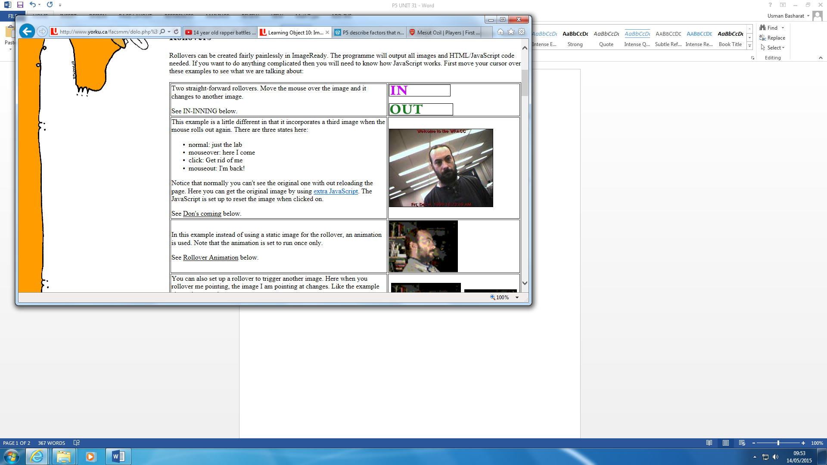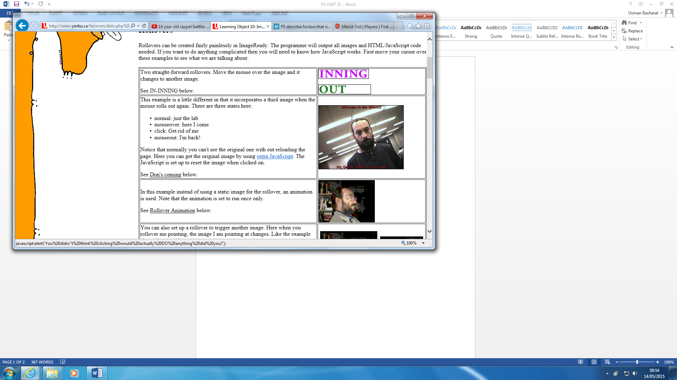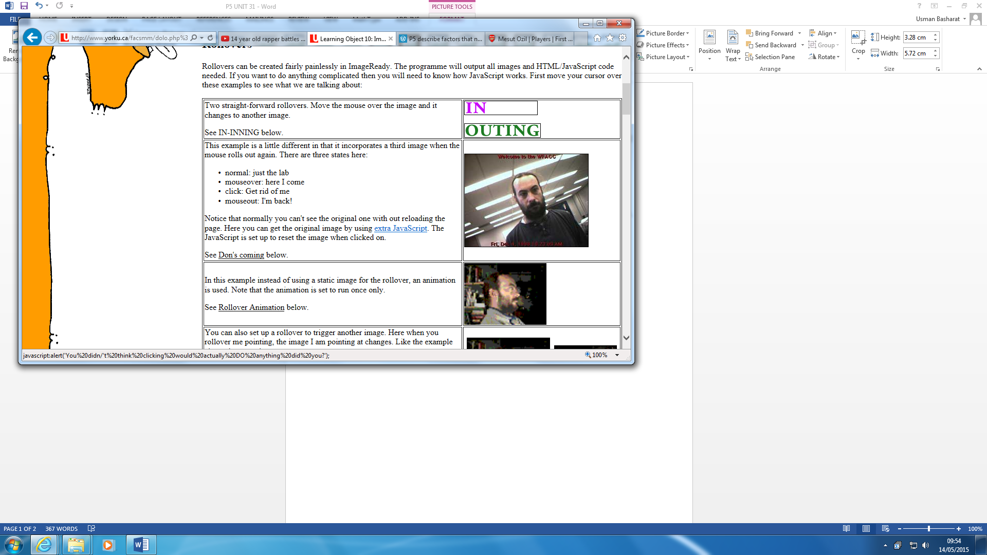

Cursor not being rollover

**Output device**

Mobile & Monitor

Animation can be differently shown on both output devices. With a mobile phone, the size of it is generally smaller than a mobile phone. Therefore, the quality of the phone reduces. Another factor is that some websites have a ‘mobile view’ of the website. Therefore, most animations will not be available on the mobile phone than the monitor. The factor affecting the monitor is depending on how updated it is. For example, if I was using an old monitor; I would not be able to see the quality of the animation. It might not be available on it too.

[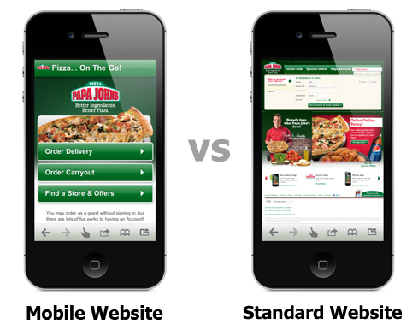](http://www.google.co.uk/url?sa=i&rct=j&q=&esrc=s&source=images&cd=&cad=rja&uact=8&ved=0CAcQjRw&url=http://www.yourwebsolutions.com/services/mobile-website-design/&ei=x8BVVYSGHsmu7Aby8oHIBQ&bvm=bv.93564037,d.ZGU&psig=AFQjCNGV2efbCHO4iJFqdBTHgNivejHqKQ&ust=1431769664763045)[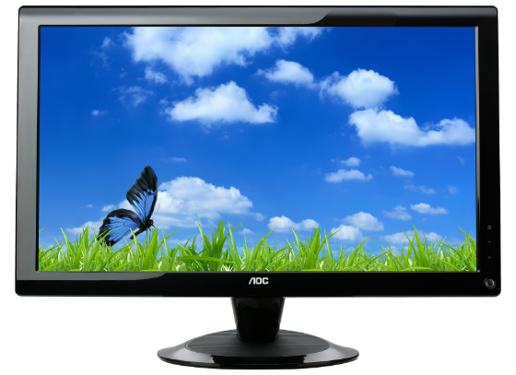](http://www.google.co.uk/url?sa=i&rct=j&q=&esrc=s&source=images&cd=&cad=rja&uact=8&ved=0CAcQjRw&url=http://us.aoc.com/monitor_displays/2036sa&ei=ocBVVYiZK5OM7Aa6zYKIBw&bvm=bv.93564037,d.ZGU&psig=AFQjCNEu06h9_SOOsTvTM_XEJYsJa8iOCw&ust=1431769623405669)

**File Type** e.g. JPG, BMP

A file format is a standard code that is encoded for storage in a computer file. Each standard code are different to each other such as BMP, GIF. They are completely different from each other and have different storage available. They are many file formats and the image below shows how many they could be. If the file type is saved as a BMP (bitmap, the animation would lose some of its quality. The file size could affect how the file type is used. If the animation was saved as a JPEG, it could be large, but if it was another file type, it would be varied. If you save a BMP image, an example, it would be around 2305KB, however if the same image was saved as a JPG; it would be 445KB. The difference between the two is that they are both compressed differently. This could affect the animation by it losing quality of the animation.

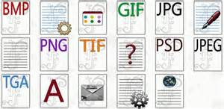

**File Size**

File size depends on which format it is used. Each different format differs from each format. As you can see below, this illustrates the different file size and some examples of it. However, the quality matters for each of the files. Also, it differs from each other e.g. 100% would be 446KB; 90% would be 216KB. As you can see the pattern, it decreases each time the quality loses. The higher the quality, the more the file size would be.

|  |  |  |  |  |
| --- | --- | --- | --- | --- |
| BMP | GIF | JPG | PNG | TIF |
| 2305KB | 209KB | 445KB | 375KB | 2039KB |
| 100% | **90%** | **80%** | **70%** | **60%** |
| 446KB | 216KB | 203KB | 175KB | 116KB |

**M3 – Explain particular techniques that are used to minimise the file size of animations**

**File Type** e.g. JPG, BMP

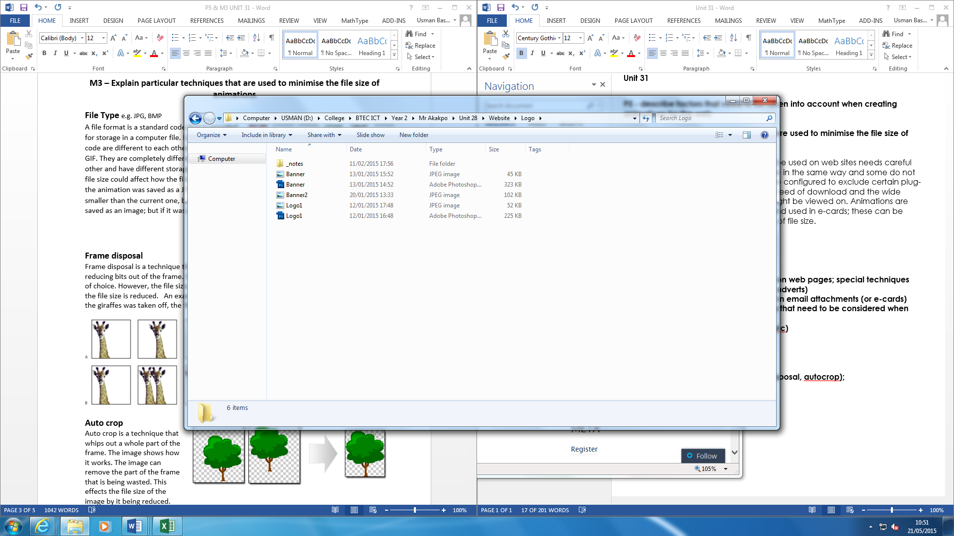A file format is a standard code that is encoded for storage in a computer file. Each standard code are different to each other such as BMP, GIF. They are completely different from each other and have different storage available. The file size could affect how the file type is used. If the animation was saved as a JPEG, it could be smaller than the current one, because it is being saved as an image; but if it was another file type, it would be varied. An example is shown below.

**Special Techniques**

**Frame disposal**

Frame disposal is a technique that is used on software such as Adobe Photoshop by reducing bits out of the frame. Some parts can be removed because it is unnecessary, or out of choice. However, the file size can be effected too. If some parts of the frame is taken off, the file size is reduced. An example is shown below of how frame disposal works. If one of the giraffes was taken off, the file size would be reduced. This is show it works.

[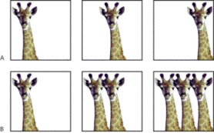](http://www.google.co.uk/url?sa=i&rct=j&q=&esrc=s&source=images&cd=&cad=rja&uact=8&ved=0CAcQjRw&url=http://u-31-as2-m3-callumreed.wikispaces.com/Wiki+3+-+Frame+Disposal&ei=C6BdVaCIMuPB7gbj-oOgAQ&bvm=bv.93756505,d.ZGU&psig=AFQjCNHGT-D8RBpuODVVnDmVvHiJ89a4Mw&ust=1432285313557807)

[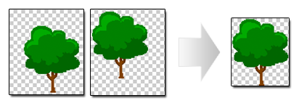](https://www.google.co.uk/url?sa=i&rct=j&q=&esrc=s&source=images&cd=&cad=rja&uact=8&ved=0CAcQjRw&url=https://www.codeandweb.com/texturepacker/starling&ei=7KFdVYilD4S37AaP14GYCw&bvm=bv.93756505,d.ZGU&psig=AFQjCNES-UzmqUroRv8ZYBLx7VQc1qCEDA&ust=1432286033134238)**Auto crop**

Auto crop is a technique that whips out a whole part of the frame. The image shows how it works. The image can remove the part of the frame that is being wasted. This effects the file size of the image by it being reduced

**Compression**

**Sound file types** e.g. wav, mp3

Sound file types is a file type that is used to store audio. The types that I will refer to is WAV and MP3. They are stored differently. Waveform Audio File Format that is used on Windows. This typically stores uncompressed audios. This is a lossless compression. However, other compression types, i.e. Lossy, is MP3. The picture below shows the difference between the two.

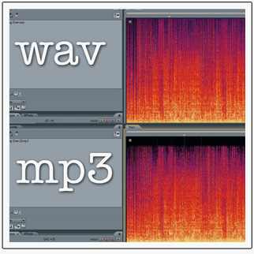

**Video and animation files** e.g. avi, swf

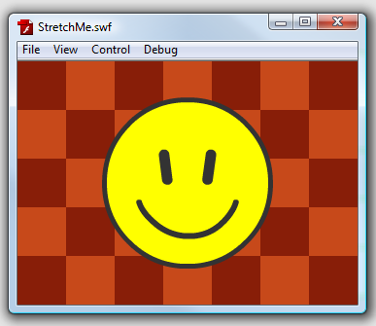AVI stands for Audio Video Interleave. It is a popular file format use for Windows. It is used for Video files only. For AVI, it is used for applications such as Windows Movie Maker. For animation files, SWF is used. SWF stands for small web format. This is used for Adobe Flash File where animation content is created and SWF file format is used.

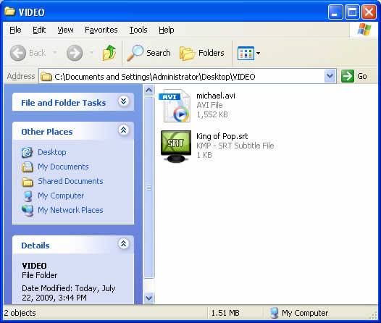

**Quality of Image**

**Vector Graphics**

Figure 1.1

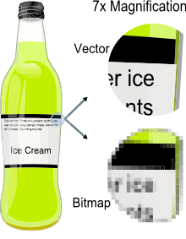Vector is a graphic computer image that it is a scale of quality when it has been enlarged. When it is enlarged, users are focused on the vectors of the image e.g. paths, strokes. It does not lose quality when the image has been enlarged. Referring to the figure 1.1, it shows when you enlarge the image of the bottle. Vector images come out clear whereas Bitmap images does not become clear when it is enlarged. Comparing vector images to ‘JPEG’, ‘GIFs’ and ‘BMP’, it does not contain grid pixels, but it can be different as paths, strokes and curves.

**Bitmap graphics**

As said before, bitmap is a graphic compute image that uses pixels (tiny blocks), because when the image is enlarged, unlike vector graphics, it loses quality. Bitmap graphics can be used on where pixel display is common e.g. CCTV cameras. It is not HD quality, but has pixels like bitmap to be used to create a bitmap display. Referring to figure 1.1, it demonstrates how bitmap image looks like. When it is enlarged, it shows us the pixels. Unlike bitmap, vector images are clear.

**Both of these images can be displayed on any animation. Examples is shown below of Bitmap and Vector.**

[](http://www.google.co.uk/url?sa=i&rct=j&q=&esrc=s&source=images&cd=&cad=rja&uact=8&ved=0CAcQjRw&url=http://www.conitec.net/litec/work20.htm&ei=YJpdVazjOoS37AaP14GYCw&bvm=bv.93756505,d.ZGU&psig=AFQjCNEL_SwXvhkwzy-pULSAP3j0MLtbCw&ust=1432284086978661)

[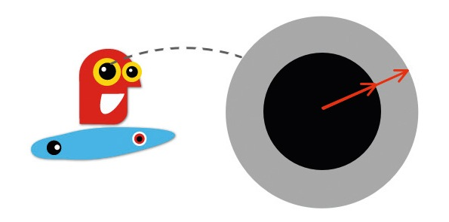](http://www.google.co.uk/url?sa=i&rct=j&q=&esrc=s&source=images&cd=&cad=rja&uact=8&ved=0CAcQjRw&url=http://www.creativebloq.com/create-slick-html5-animations-9134432&ei=hppdVeiRCund7QbFloKoDw&psig=AFQjCNErjgyJhO6us3940QrdM7SJyIs3wg&ust=1432284155597473)